Project Butterfly
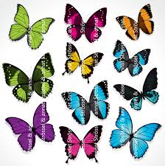

We need your help in order to manufacture a butterfly due to an exhibition. There are different methods to create a butterfly as well as there are many different kinds of butterflies. You will get the chance to advance in this course.

- Your task will be to manufacture a Inachis io in our workshop.
- Your goal is to create a model of this butterfly in the scale 3:1.
- The resources you will have is the equipment in the workshop. You can also use the internet or a library in order to learn how the butterfly looks.

You will during the work process show your work and reflect on it with your teacher in a dialogue. We will also have a joint gathering in order to reflect in group.

Presentation
You will present your butterfly at the butterfly exhibition togeter with your class later this year.

Criterias
Lifelike
Design
According to scale
As a part of the students reflection, each student will give responce on another students butterfly with their own words like ex. good, beautiful, lifelike, to big, wrong model of butterfly, what is missing or can someone done something differently? It´s very important that each student stands by what they say in their reflection.

